
Appraiser Sales

Pathfinder Business Analysis Pvt Ltd

Appraiser Sales Template:
- Appraiser Sales are completed using the Template used for Sales Uploader



Determination of Sales:
- Sales received through Mail or FTP is used for production. Highlighted is the sale taken
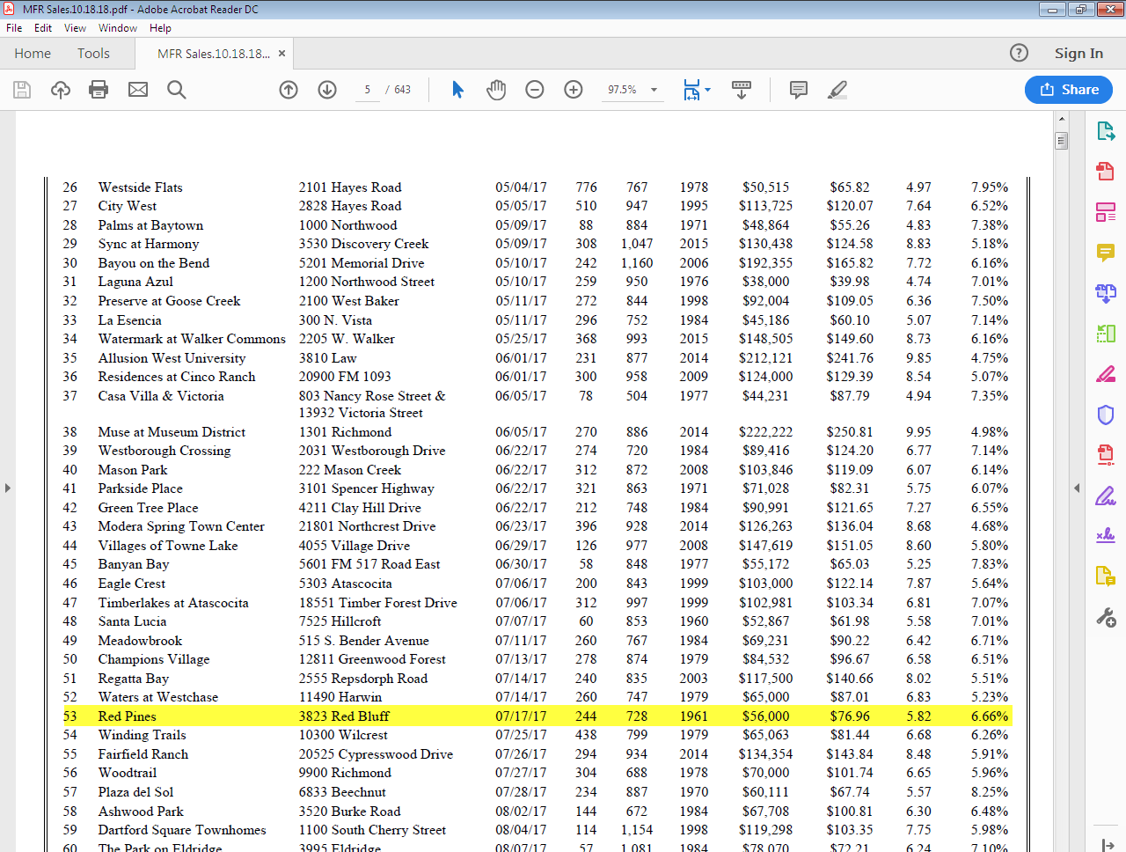
Use Ctrl + F to find the above highlighted records with Exact Address.
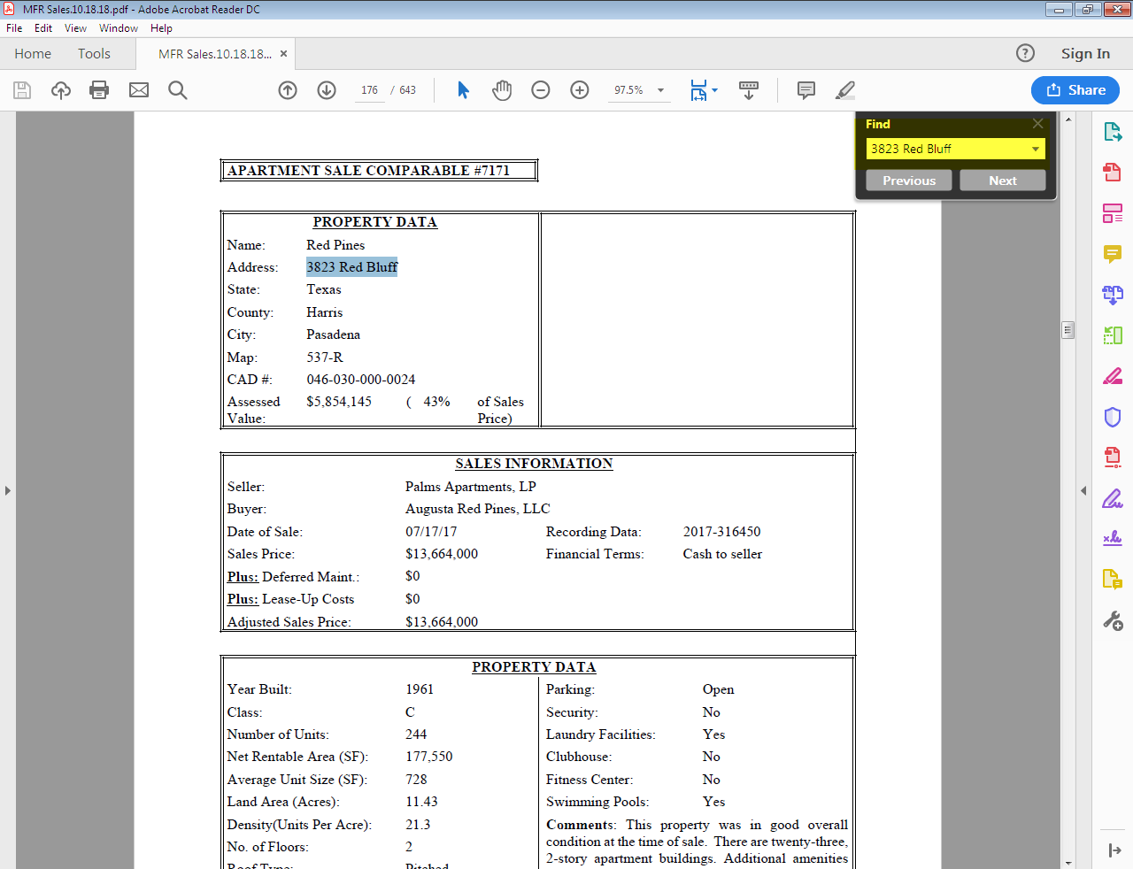

- Search the property by using the given address in the source for respective County.
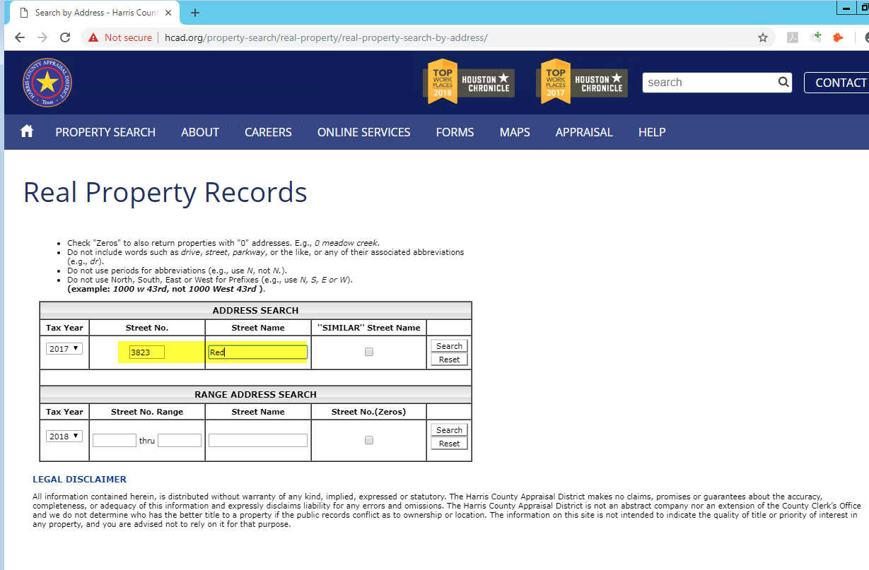
Match the property address with Account number in the Source Sheet.
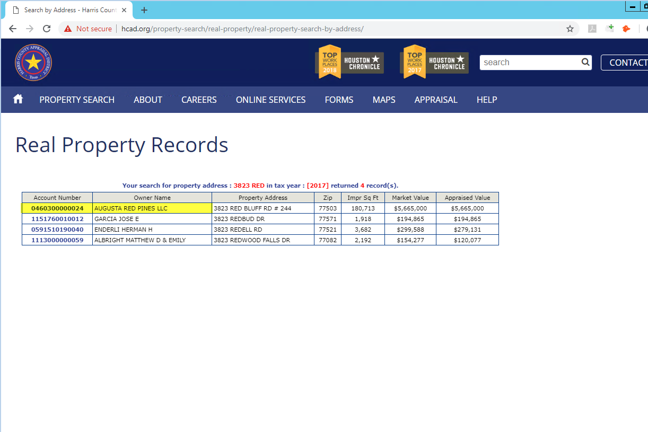

Confirming the Property & Deed with Source:
- Confirm the Owner Name, Property address, Account Number, Land Size, GBA, Year Built, Class and Key Map in the CAD with Source data.
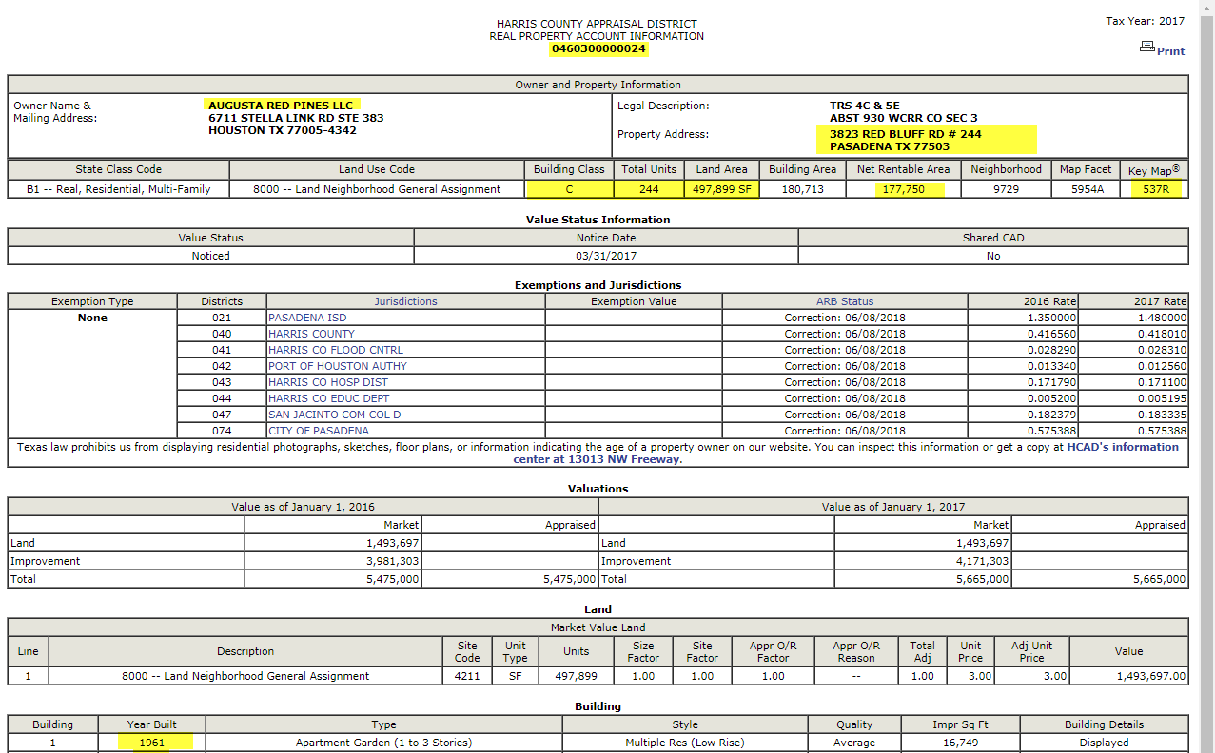
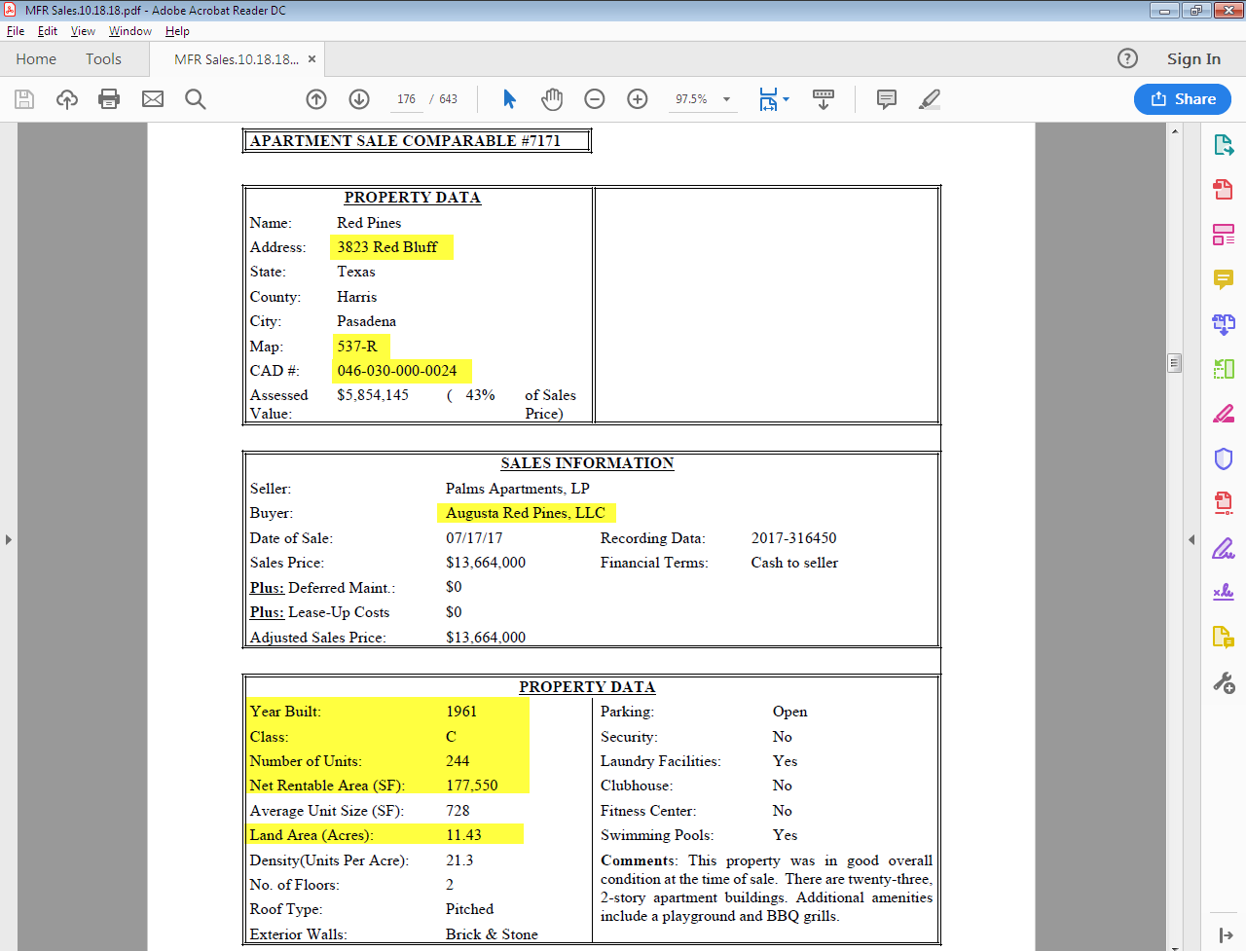

Check the Ownership history in the terms to confirm the Grantor and Grantee information.
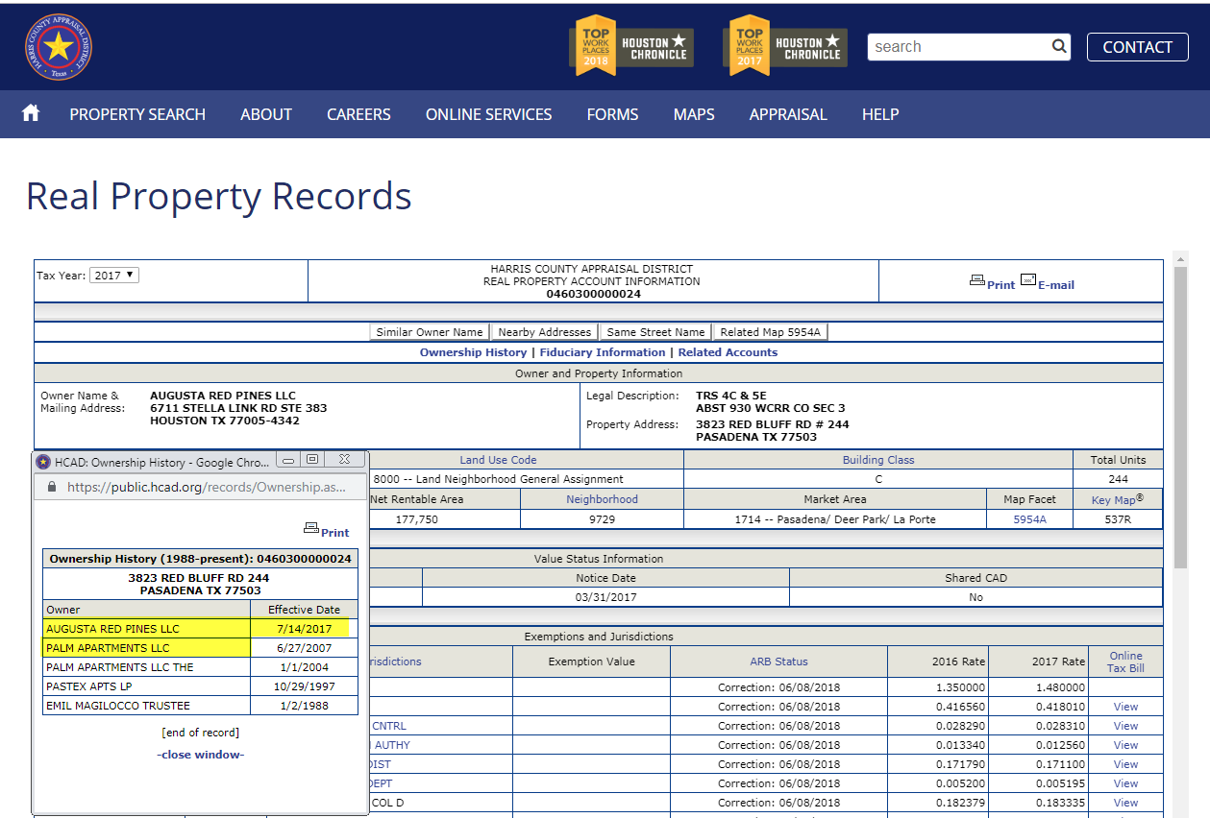
- Use the Courthouse to Verify/View the property information for confirming the Legal and Acerage in the CAD with Source
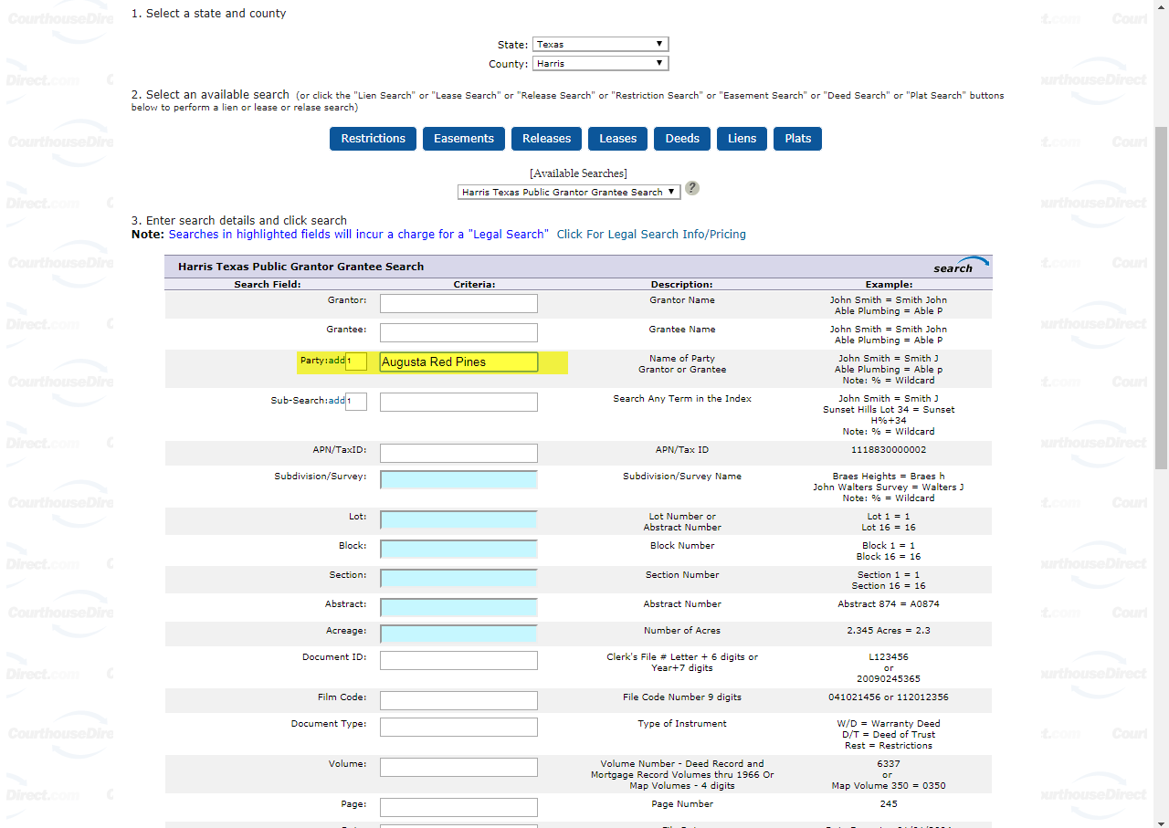
Search using anyone of the option with Grantor Name/Grantee Name/Sub division/Film Code/Document ID and even with APN (Account number) for finding the Deed/WD
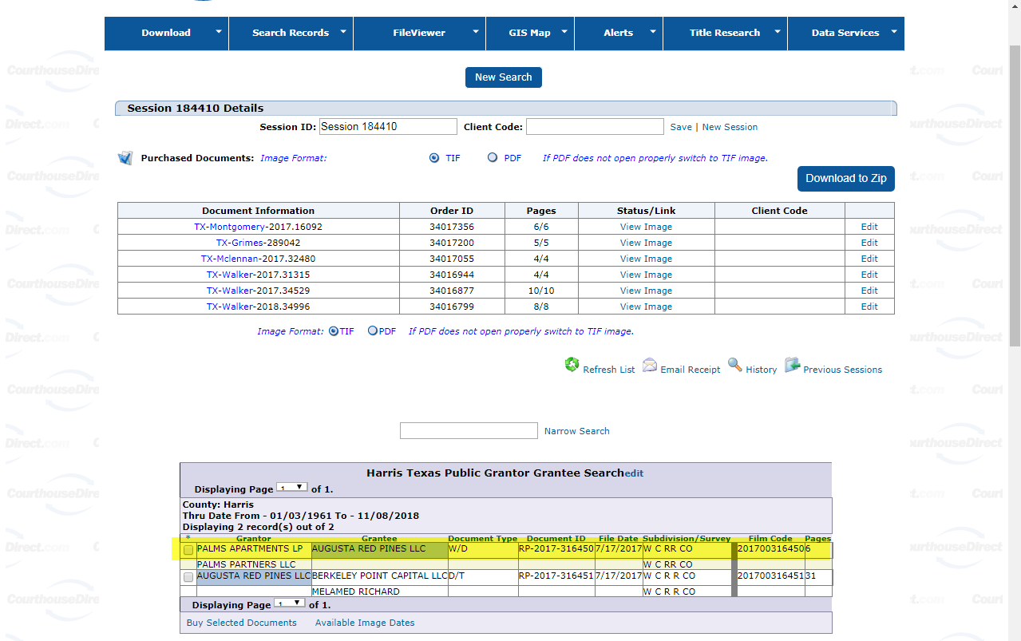
Select the check box on desired document and click the Buy Selected Documents, then select the View Image for the document to be viewed.
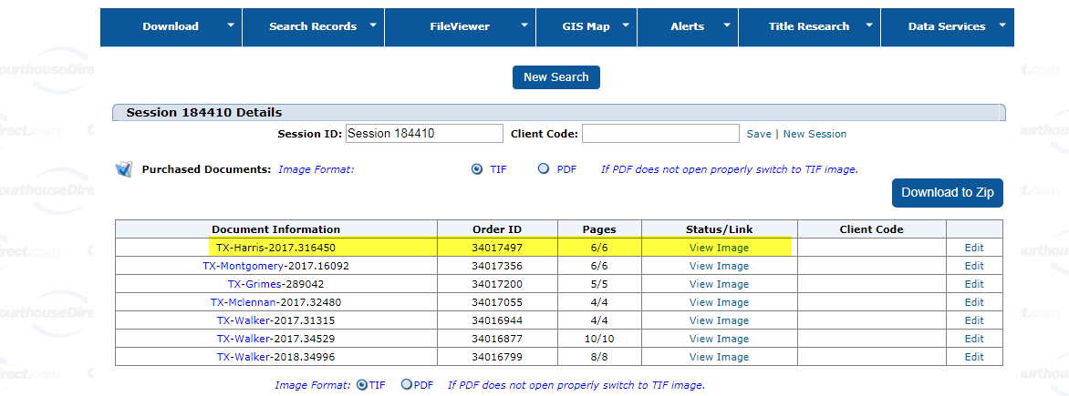

- Confirm the Deed information with Source/CAD with Grantor and Grantee ,Acreage and Legal description
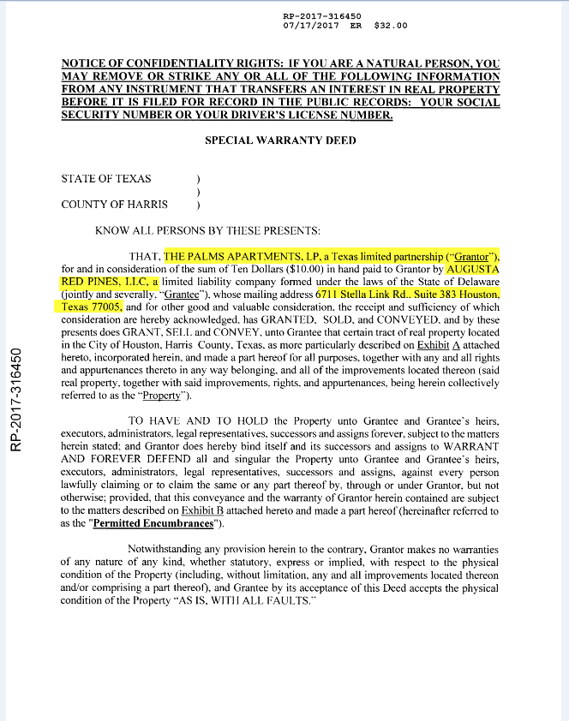

Grantor Contact person is must information in the Deed information (Signed person)

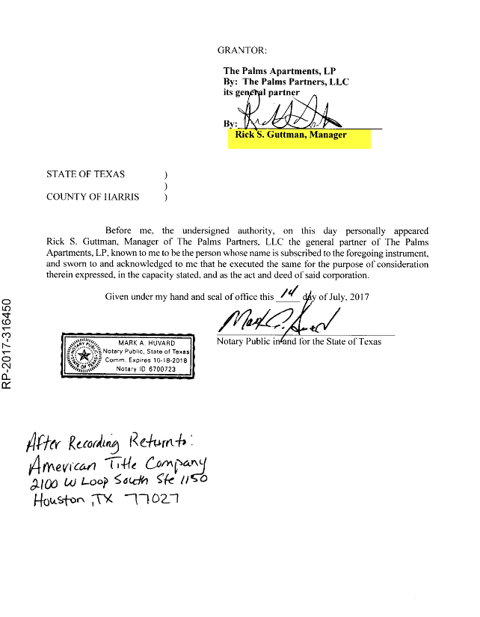

- Confirm the Property acres with Source/CAD and Legal Description of the property with Sub division
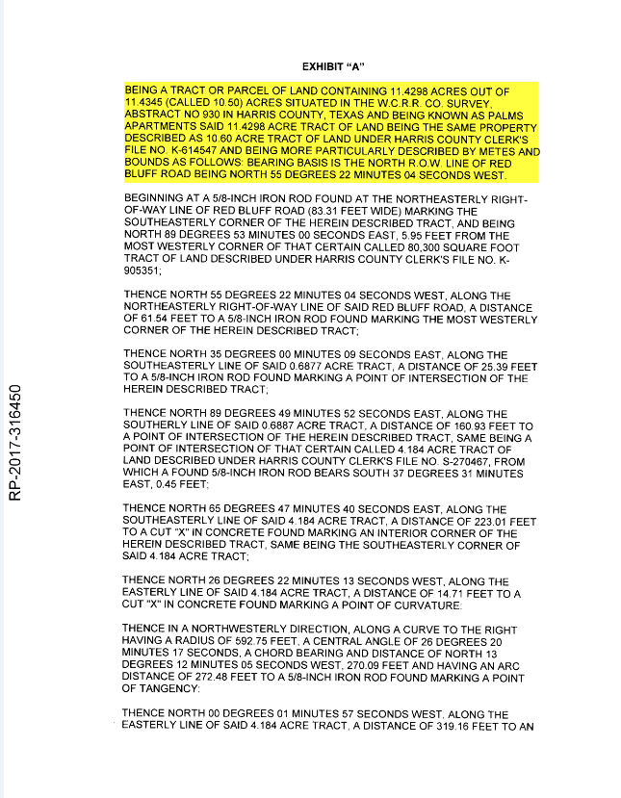

Update the Land Size as per Deed if it is given in the Deed

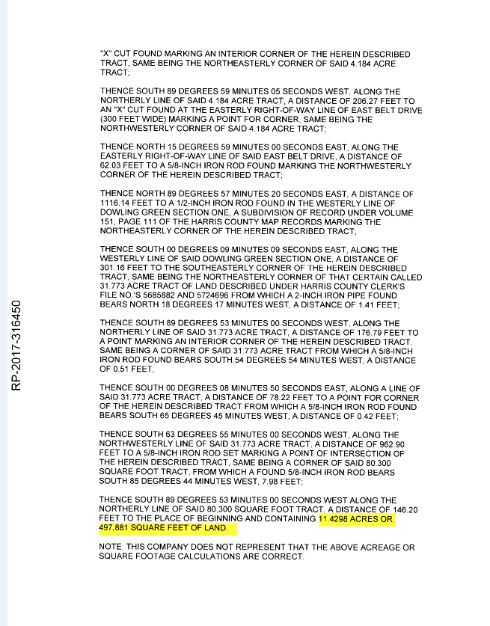

LUC & Source/Source Group ID:
- Check the LUC code available in the CAD with OCA LUC cad sheet and update in the Template.
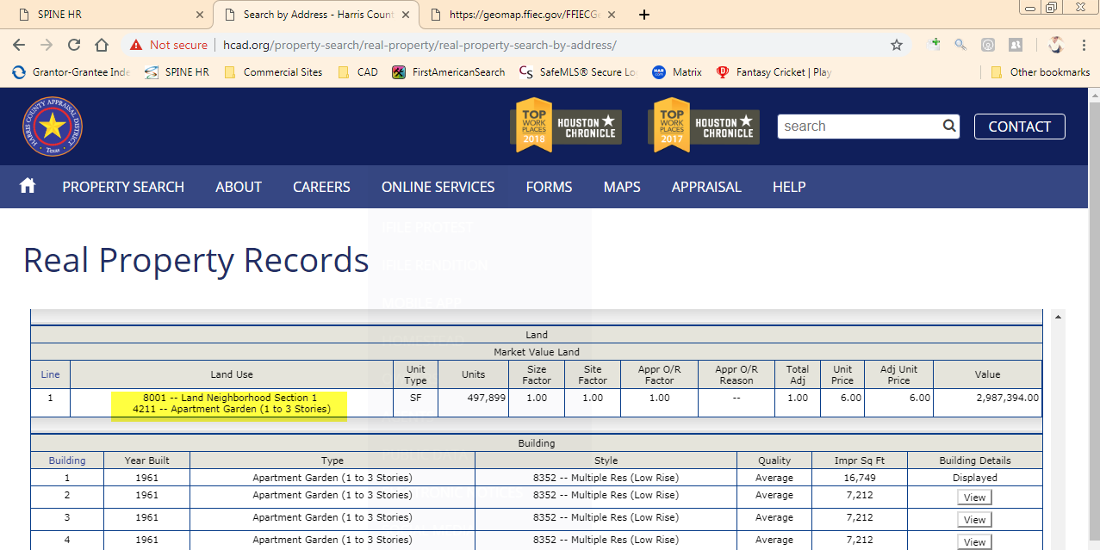

- In the fields of Source and Source Group ID are filled as “Appraiser” as default in template.

- Sale type is updated as per source, if not mentioned anything in the source. Go with “Arms-Length” unless it is not a “In-house” sale.

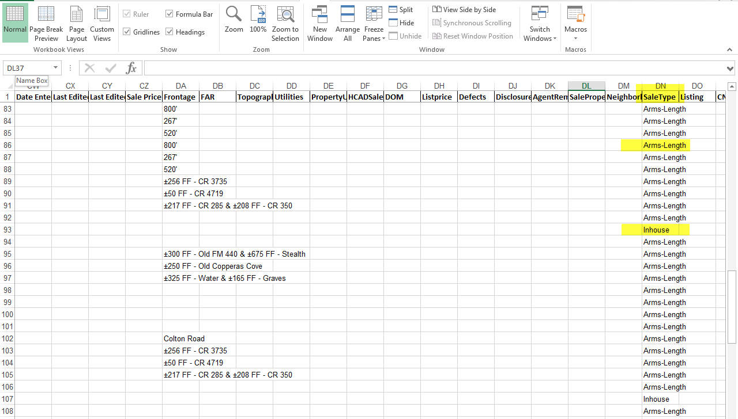
Mandatory Fields in Appraiser Sales:
- Update the highlighted data in the template at the respective fields
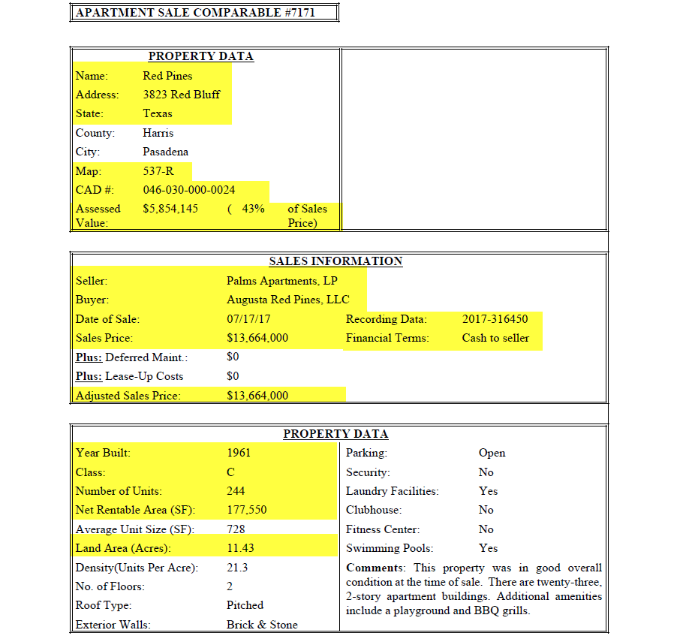
In Occupancy, only numeric value should be entered (No special Character to be entered)
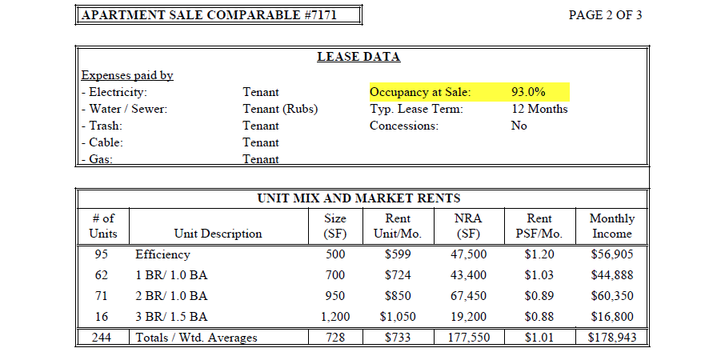

- In the Financial data’s, the value which are highlighted must be updated in the their own fields (In the field of PGI- PGRI+Other Income+RUBS Income)
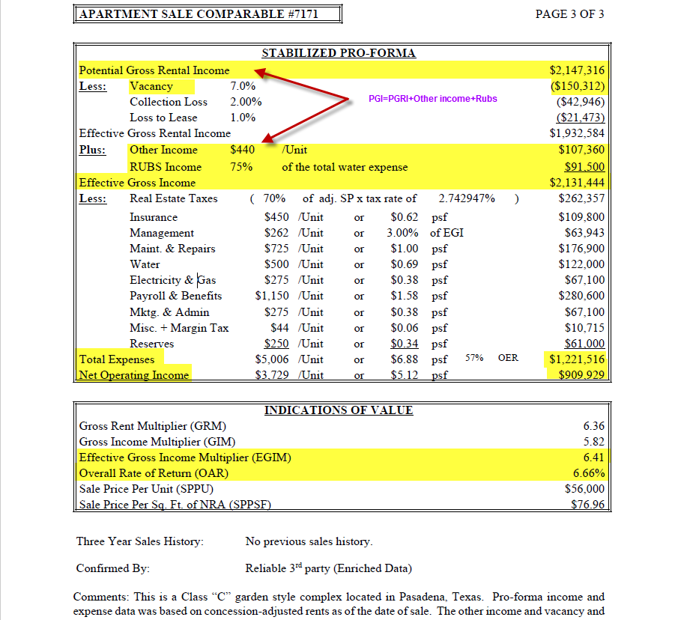

Comments/Remarks Fields in Appraiser Sales:
- Fields which are not mentioned in the Mandatory section will falls in the Remarks/Comments. Highlighted data will be updated in the remarks section.
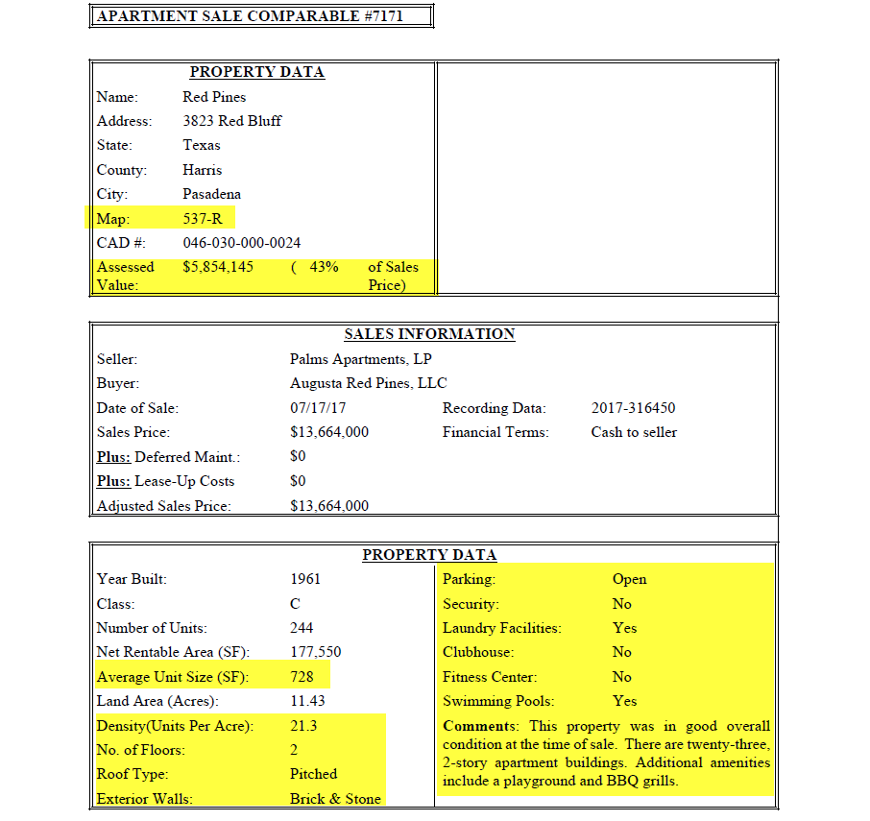

- During the update of remark section, be ensure that each comments are updated in the proper sentence format.
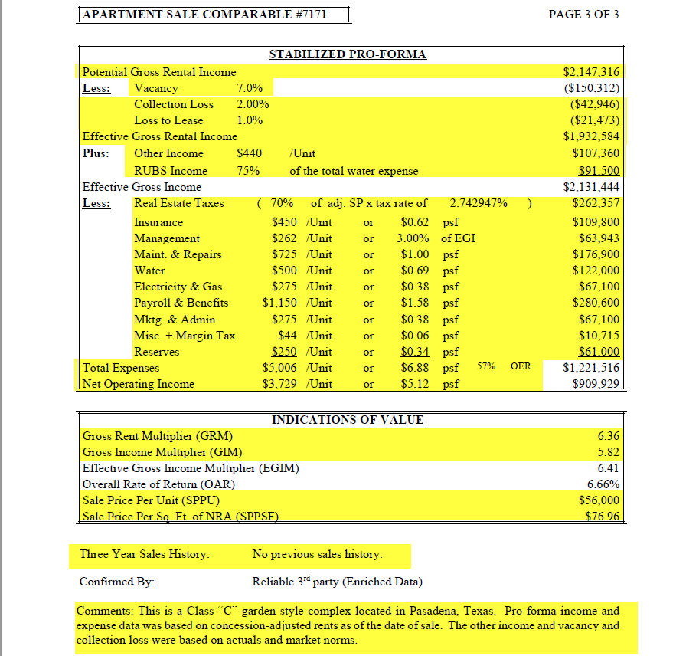

Location & Census Tract:
- Use the Google Map to locate the Property in exact direction from the near ways of roads,
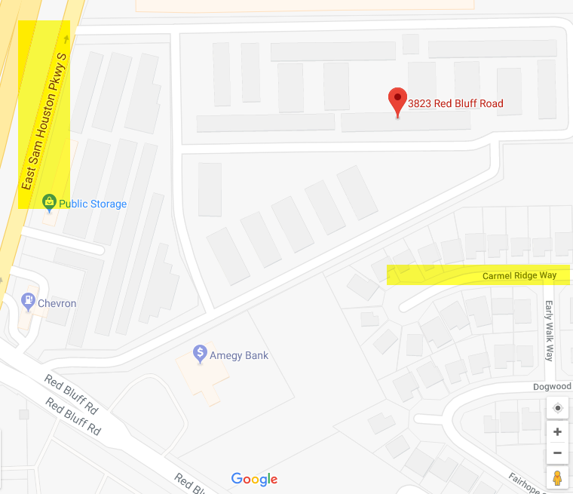

- Use the Property address in the www.geomap.ffiec.gov/FFIECGeocMap/GeocodeMap1.aspx for finding the Census tract of the region.
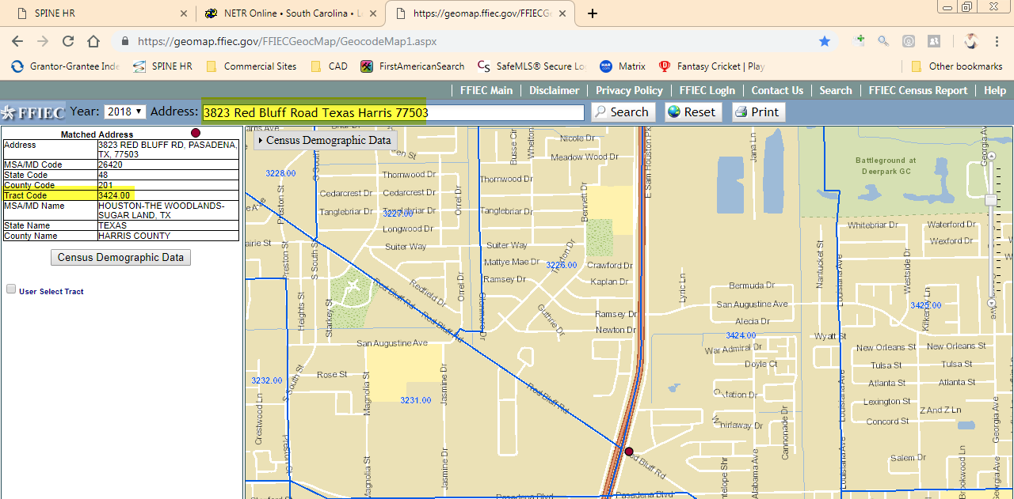

Invalid Sales:
- Acreage Mismatched- Acres should be matched with the Minimum difference of (+/- 0.05) or unless any Save and Except has been mentioned in the Deed. In remaining criteria it should be marked as Acreage Mismatch
- GBA Mismatch are case where happens only Bundle sale or huge difference with given source.
Source:
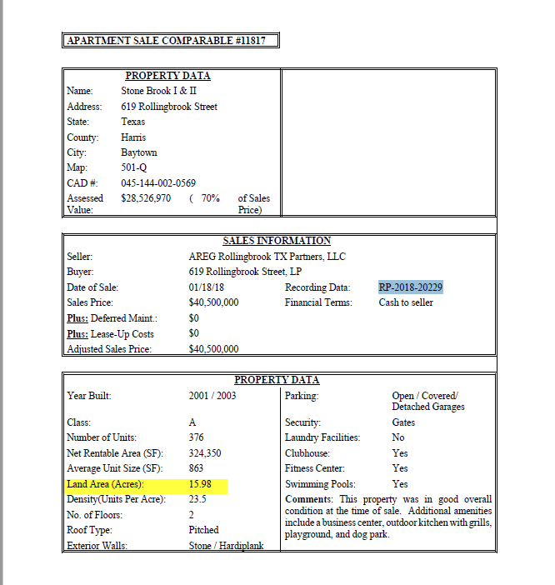

Deed:
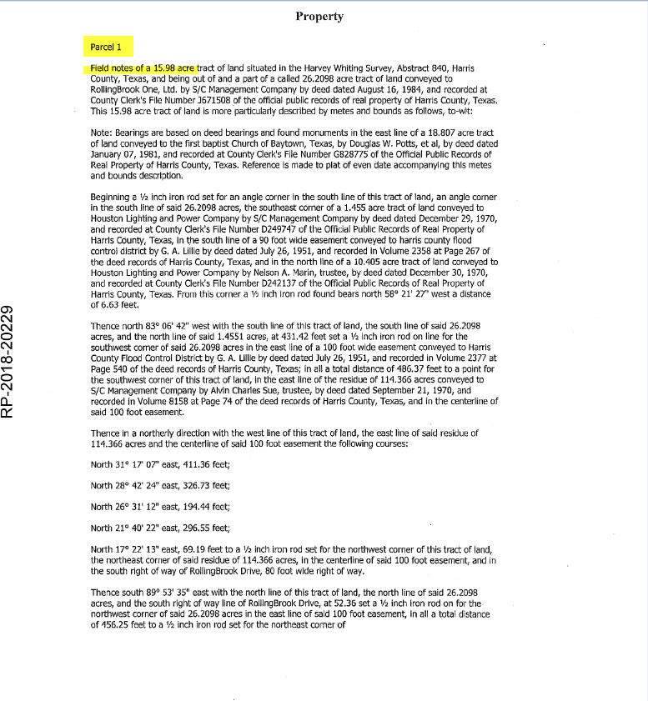

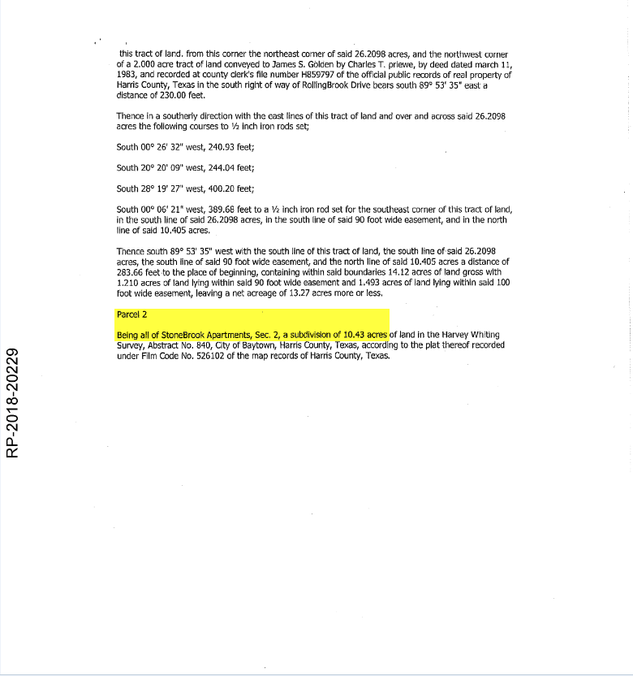
CAD:
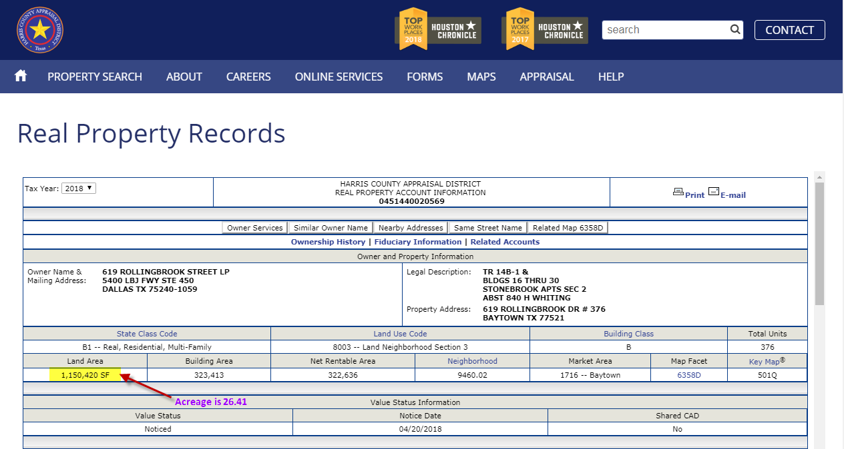

- Account not Found: In the Scenario, we can’t able to find the Property using Address, Account number and Legal Description.
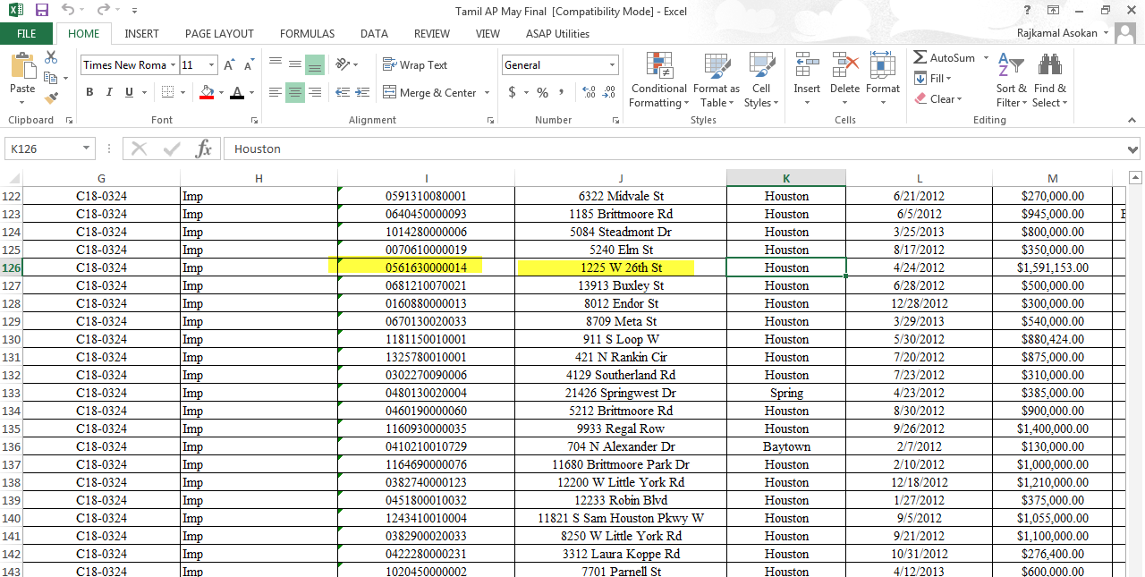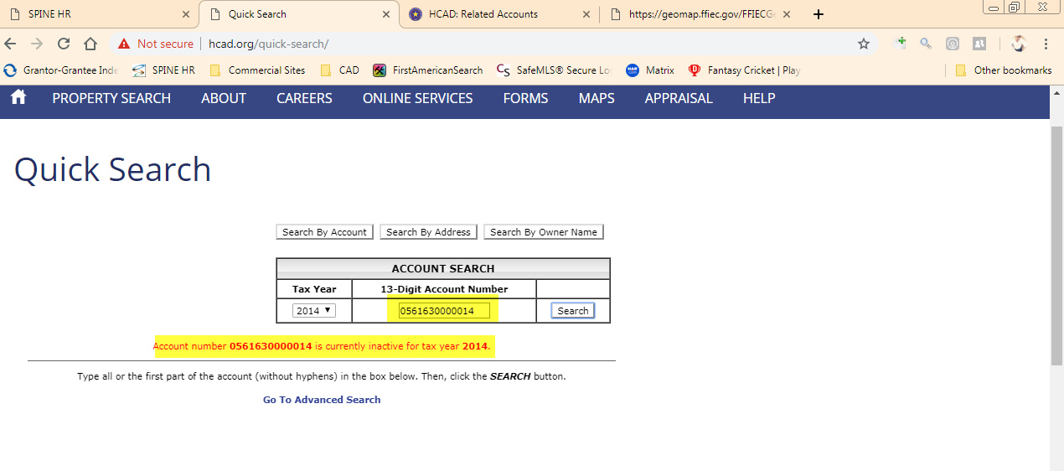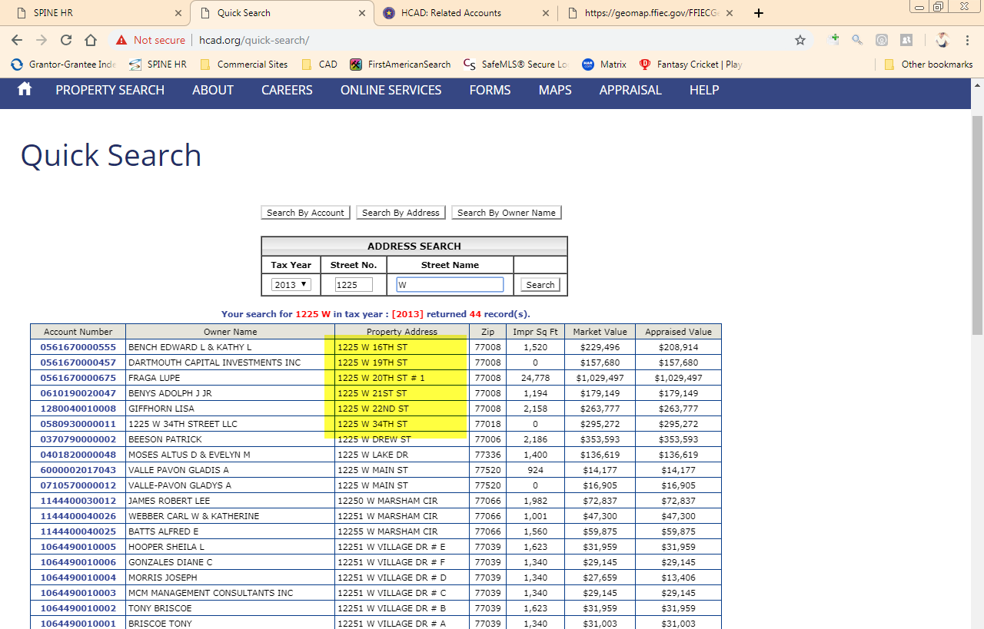

- Deed Not Available: If we are looking for particular Grantor/Grantee with the Sale Date provided in the source, in case we couldn’t able to find or Deed related to sale is not available means Deed Not Available.
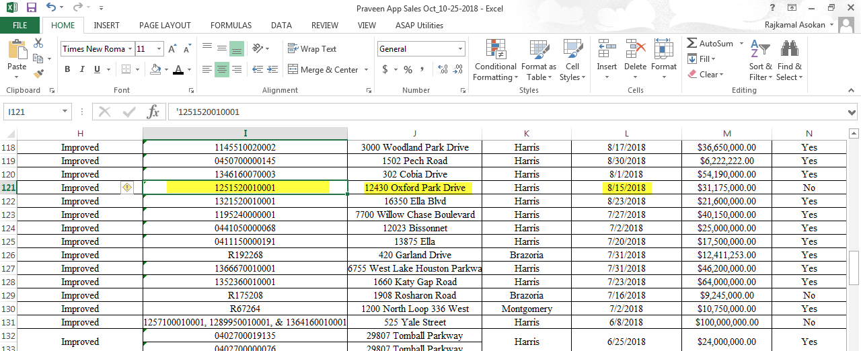
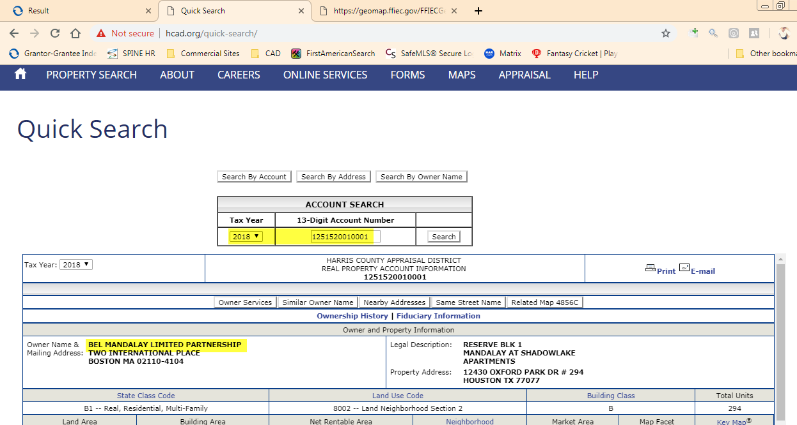
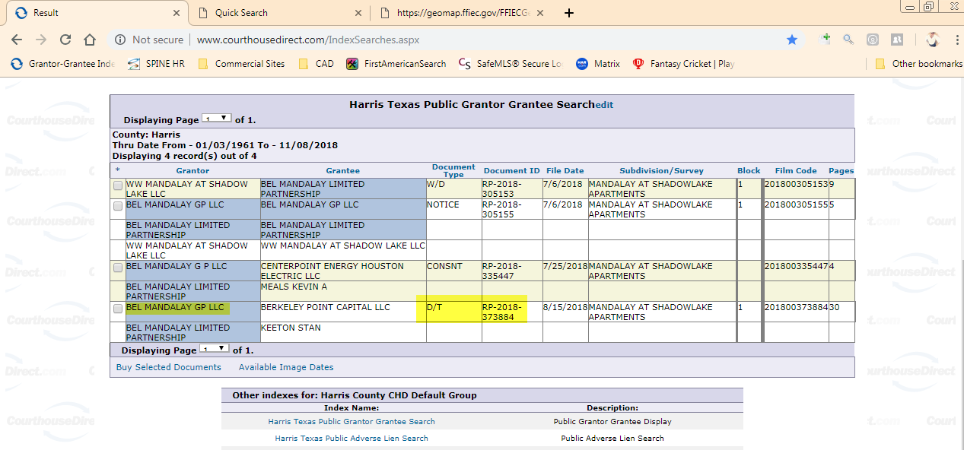
Sales Uploader and its template:
- Completed sales are uploaded to Enriched Data using Sales Uploader with desired template for sample is attached below

Sales Uploader Link


Sales Uploaded Sample files
